9 MAI – ZIUA EUROPEI

Webgrafie tematică

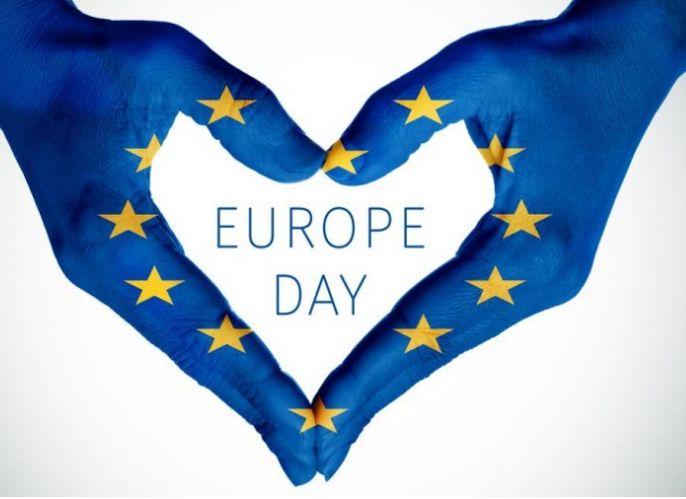

- https://ziarulunirea.ro/9-mai-ziua-europei-a-independentei-romaniei-si-sfarsitul-celui-de-al-doilea-razboi-mondial-262983/
- https://europa.eu/european-union/about-eu/symbols/europe-day_ro
- https://www.youtube.com/watch?v=BGtCll6CMaM
- https://www.stiripesurse.ro/9-mai-ziua-europei-ce-sarbatorim-de-fapt_652035.html
- https://www.europafm.ro/9-mai-ziua-europei/
- https://www.mediafax.ro/externe/cand-este-sarbatorita-ziua-europei-si-ce-semnificatie-are-16201290

