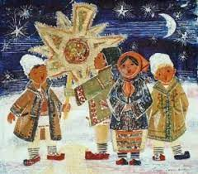
Colinde, colinde
webgrafie tematica

Webgrafie realizata de
Bibliotecar CCD Neamt
Ana Macovei

- Colinde (versuri si partituri) https://lumeatinerilor.files.wordpress.com/2015/12/colinde.pdf
- Colinde-versuri https://www.academia.edu/35711128/Colinde
- Colinde bisericesti https://vdocuments.mx/ioan-brie-colinde.html
- Versuri tematice https://www.academia.edu/35593208/Colinde_Colinde
- Colinde-partituri https://fdocuments.in/document/partituri-cor-colinde.html
- Obiceiul colindului- prezentare https://vdocuments.mx/colinde-religioase.html
- Deschide usa, crestine- colinde https://vdocuments.mx/carticica-cu-colinde.html
- Colinde –versuri https://vdocuments.mx/reader/full/colinde-2010-vers
- Culegere de colinde https://vdocuments.mx/culegere-de-colinde.html
- Colinde in Limba engleza https://vdocuments.mx/colinde-in-englezaa.html
- Colinde https://www.slideshare.net/apostolcrinacristina/colinde-2016
- Colinde de Craciun https://agrointel.ro/170358/versuri-colinde-craciun-romanesti/
- Video-colinde https://doxologia.ro/biblioteca/colinde
- Corul Madrigal- Colinde https://www.youtube.com/watch?v=BrY96R8emSo
- Cantari de stea si colinde http://dspace.bcucluj.ro/handle/123456789/68413

